**INFOLABZ IT SERVICES PVT. LTD.**

**Course :** React

**Session No :** –

**Topics to be covered :** Class Components

Class components in react are inbuilt classes which are extended from Component of react package.

**We have to import**

Import { Component } from ‘react’;

**Syntax :**

class App extends Component{

render(){

return(){

<div>

<h1> Class component in react </h1>

</div>

}

}

}

**Create new project : classcomponents**

Create New file : customcomps.js inside source folder

( right click on src folder > New file > write customcomps.js )

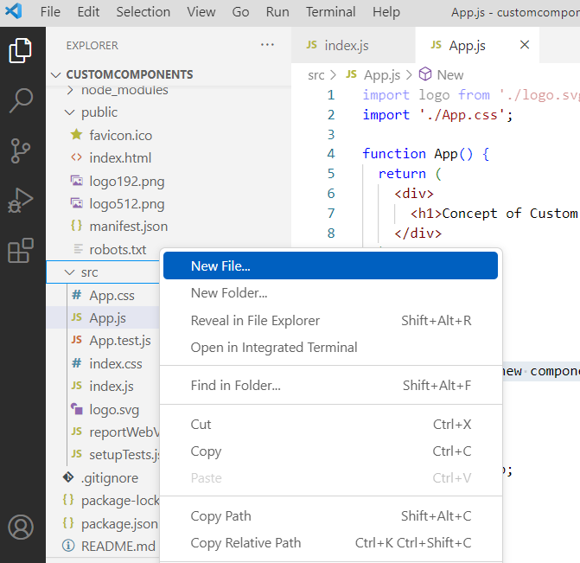 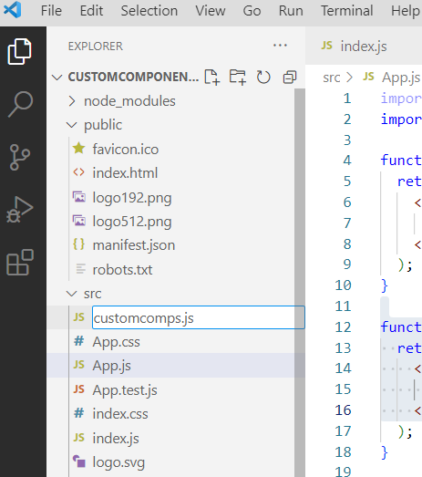

App.js

( Creating 2 class components App and New in app.js file )

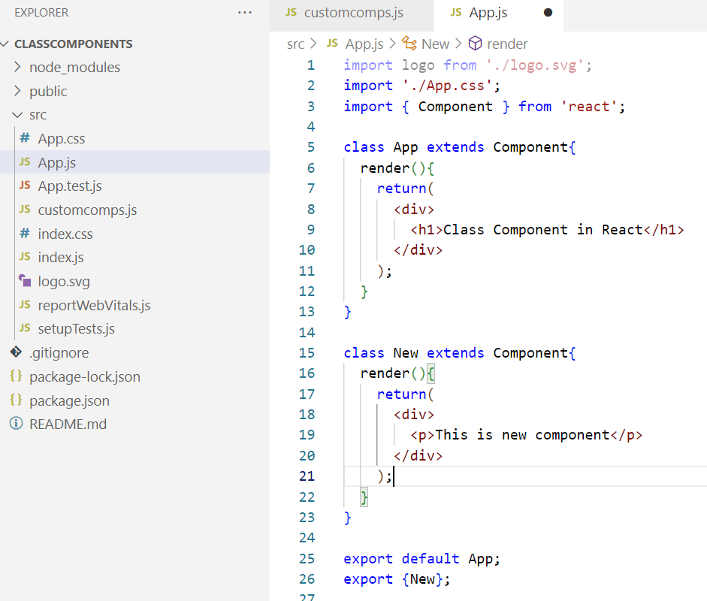

Index.js

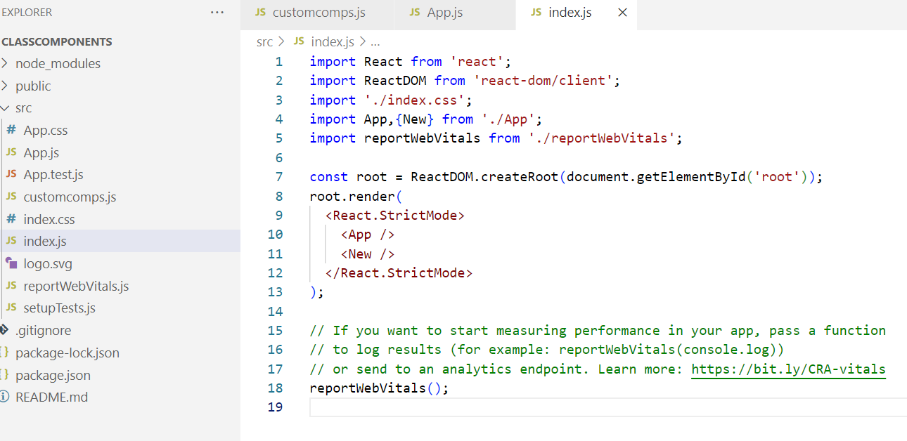

Output:

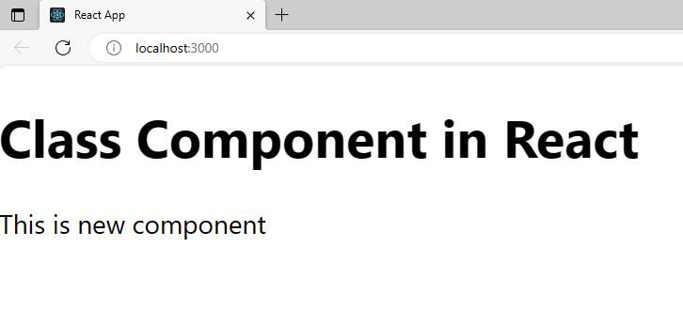

**Complete this project based on following Structured Representation :**

| **Create New react project :mixcomponentone** | |
| --- | --- |
| **App.js** | App [ Second ] (DE), New [ Third ] (E), Next (E) |
| **Customcomps.js** | First (DE), Second (E), Third (E), Fourth(XE), Fifth [Fourth,Next] (E) |

| **Create New react project :mixcomponentstwo** | |
| --- | --- |
| **App.js** | **App (DE)** [Add], New (E) [Sub] |
| **Calc.js** | **Add(DE)**, Sub (E) , **Mul**(XE), Div(E) [Mul] |
| **BOLD : Functional Components**  Underline : Class Components  Add 2 javascript variables for addition subtraction …. etc | |